**Lesson 10 Demo 2**

**Creating First Terraform Script**

**Objective:** To create a Terraform script to launch an AWS EC2 instance.

**Prerequisites:** You need to have Terraform installed in your lab environment. If it is not installed, refer to demo 1 of lesson 10 to install Terraform.

**Tools required:** Terraform

**Steps to be performed:**

1. Creating a Terraform script to launch an AWS EC2 instance

**Step 1: Creating a Terraform script to launch an AWS EC2 Instance**

1. Create a folder where you will create the Terraform script

***mkdir TerraformScript***

***cd TerraformScript***

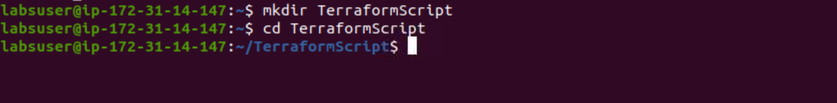

1. Run the following command to create a Terraform script to launch a new AWS EC2 instance

***sudo vi awsec2.tf***



1. Add the following code in your Terraform script where you define the provider and resources to launch an AWS EC2 instance:

***provider "aws" {***

***access_key = "<Your_Access_Key>"***

***secret_key = "<Your_Secret_Key>"***

***token = "<Your_Security_Token>"***

***region = "us-east-1"***

***}***

***resource "aws_instance" "terraform_demo" {***

***ami = "ami-09e67e426f25ce0d7"***

***instance_type = "t2.micro"***

***}***

In the configuration mentioned above, mention the provider as AWS. Inside the provider, give AWS user credentials and regions where the instance must be launched.

In resources, give the AMI details of Ubuntu and mention the instance type as t2.micro

1. Save and close the file
2. You have successfully created your first Terraform script to launch a new AWS EC2 instance